The Holy Eucharist
The Fifth Sunday after the Epiphany: proper 5

FEBRUARY 4, 2024 · 10:00 AM

Welcome to St. John’s, Shaughnessy! Wherever you are on your spiritual journey, and whether you are joining us in the church building or via the livestream, we are glad you are here!
If you are new here and would like to learn more, please introduce yourself to the clergy after the service. If you would like to be added to our mailing list so that we may keep you informed of upcoming events, please contact the church office.
Infants and children (and their accompanying noises) enliven our services. Colouring, crafts, and quiet toys are available in the children’s area, just to the left of the front pews.
We acknowledge with respect that we worship on the traditional, ancestral, and unceded territory of the Coast Salish Peoples, and we pray that we may live more deeply into the calls to action from Canada’s Truth and Reconciliation Commission.
A brief organ voluntary offered a few minutes before the hour bids us all keep silence for prayer and preparation.
The people’s responses are in bold.
Prelude Fantasia in F: Adagio W.A. Mozart (1756-1791)

Greeting
Please stand as you are able.
The Entrance Rite
Hymn Lobe den Herren
The Opening Acclamation
The grace of our Lord Jesus Christ, and the love of God,
and the fellowship of the Holy Spirit, be with you all.
And also with you.

The Collect for Purity
Almighty God, to you all hearts are open, all desires known, and from you no secrets are hidden. Cleanse the thoughts of our hearts
by the inspiration of your Holy Spirit, that we may perfectly love you, and worthily magnify your holy name; through Christ our Lord. Amen.

Song of Praise Song 42
The Collect of the Day
Merciful Lord, grant to your faithful people pardon and peace, that we may be cleansed from all our sins and serve you with a quiet mind; through Jesus Christ our Lord, who is alive and reigns with you and the Holy Spirit, one God, now and for ever. Amen.
Please be seated.
The Liturgy of the word
The First Reading Isaiah 40:21-31
A reading from the Book of Isaiah
Have you not known? Have you not heard? Has it not been told you from the beginning? Have you not understood from the foundations of the earth? It is he who sits above the circle of the earth, and its inhabitants are like grasshoppers; who stretches out the heavens like a curtain, and spreads them like a tent to live in; who brings princes to naught, and makes the rulers of the earth as nothing. Scarcely are they planted, scarcely sown, scarcely has their stem taken root in the earth, when he blows upon them, and they wither, and the tempest carries them off like stubble. To whom then will you compare me, or who is my equal? says the Holy One. Lift up your eyes on high and see: Who created these? He who brings out their host and numbers them, calling them all by name; because he is great in strength, mighty in power, not one is missing. Why do you say, O Jacob, and speak, O Israel, “My way is hidden from the Lord, and my right is disregarded by my God”? Have you not known? Have you not heard? The Lord is the everlasting God, the Creator of the ends of the earth. He does not faint or grow weary; his understanding is unsearchable. He gives power to the faint, and strengthens the powerless. Even youths will faint and be weary, and the young will fall exhausted; but those who wait for the Lord shall renew their strength, they shall mount up with wings like eagles, they shall run and not be weary, they shall walk and not faint.
Hear what the Spirit is saying to God’s people.
Thanks be to God.
Psalm 147 1-12, 20-21 Laudate Dominum Setting: Frederick A. Gore Ouseley
¹ Hallelujah! How good it is to sing praises to our God!
how pleasant it is to honour him with praise!
² The Lord rebuilds Jerusalem;
he gathers the exiles of Israel.
³ He heals the brokenhearted
and binds up their wounds.
⁴ He counts the number of the stars
and calls them all by their names.
⁵ Great is our Lord and mighty in power;
there is no limit to his wisdom.
⁶ The Lord lifts up the lowly,
but casts the wicked to the ground.
⁷ Sing to the Lord with thanksgiving;
make music to our God upon the harp.
⁸ He covers the heavens with clouds
and prepares rain for the earth;
⁹ He makes grass to grow upon the mountains
and green plants to serve mankind.
¹⁰ He provides food for flocks and herds
and for the young ravens when they cry.
¹¹ He is not impressed by the might of a horse,
he has no pleasure in the strength of a man.
¹² But the Lord has pleasure in those who fear him,
in those who await his gracious favour. Hallelujah!
The Second Reading 1 Corinthians 9:16-23
A reading from the first letter of Paul to the Corinthians
If I proclaim the gospel, this gives me no ground for boasting, for an obligation is laid on me, and woe to me if I do not proclaim the gospel! For if I do this of my own will, I have a reward; but if not of my own will, I am entrusted with a commission. What then is my reward? Just this: that in my proclamation I may make the gospel free of charge, so as not to make full use of my rights in the gospel. For though I am free with respect to all, I have made myself a slave to all, so that I might win more of them. To the Jews I became as a Jew, in order to win Jews. To those under the law I became as one under the law (though I myself am not under the law) so that I might win those under the law. To those outside the law I became as one outside the law (though I am not free from God's law but am under Christ's law) so that I might win those outside the law. To the weak I became weak, so that I might win the weak. I have become all things to all people, that I might by all means save some. I do it all for the sake of the gospel, so that I may share in its blessings.
Hear what the Spirit is saying to God’s people.
Thanks be to God.

Please stand as you are able.
Hymn at the Sequence Aberystwyth
The Gospel Acclamation
The Cantor sings the Alleluia; then all repeat.
Cantor He took our infirmities and bore our diseases. Alleluia
The Holy Gospel Mark 1:29-39
The Lord be with you.
And also with you.
The Holy Gospel of our Lord Jesus Christ, according to Mark.
Glory to you, Lord Jesus Christ.
As soon as they left the synagogue, they entered the house of Simon and Andrew, with James and John. Now Simon's mother-in-law was in bed with a fever, and they told Jesus about her at once. He came and took her by the hand and lifted her up. Then the fever left her, and she began to serve them. That evening, at sundown, they brought to him all who were sick or possessed with demons. And the whole city was gathered around the door. And he cured many who were sick with various diseases, and cast out many demons; and he would not permit the demons to speak, because they knew him. In the morning, while it was still very dark, he got up and went out to a deserted place and there he prayed. And Simon and his companions hunted for him. When they found him, they said to him, “Everyone is searching for you.” He answered, “Let us go on to the neighbouring towns, so that I may proclaim the message there also; for that is what I came out to do.” And he went throughout Galilee, proclaiming the message in their synagogues and casting out demons.
The Gospel of Christ.
Praise to you, Lord Jesus Christ.
Please be seated.
The Sermon The Rev. Terry Shields Dirbas

Please stand as you are able.
The Apostles’ Creed
I believe in God, the Father almighty, creator of heaven and earth.
I believe in Jesus Christ, his only Son, our Lord. He was conceived by the power of the Holy Spirit and born of the Virgin Mary. He suffered under Pontius Pilate, was crucified, died, and was buried.
He descended to the dead. On the third day he rose again. He ascended into heaven, and is seated at the right hand of the Father. He will come again to judge the living and the dead.
I believe in the Holy Spirit, the holy catholic Church, the communion of saints, the forgiveness of sins, the resurrection of the body, and the life everlasting. Amen.
Please remain standing or kneel, as you are able.
The Prayers of the People
In the name of Jesus of Nazareth, let us pray for all who need the cleansing power of the Holy One of God.
For the peace from above, for the loving-kindness of God, and for the salvation of our souls, let us pray to the Lord.
Lord, have mercy.
For the peace of the world, for the welfare of the holy Church of God, and for the unity of all peoples, let us pray to the Lord.
Lord, have mercy.
For Justin, the Archbishop of Canterbury; Linda, our Primate; Chris, the National Indigenous Archbishop; and John, our bishop; in the Anglican Cycle of Prayer, for the Anglican Church of South America; in the Diocese of New Westminster: St Brigid @ Christ Church Cathedral; the Standing Committee on Mission and Ministry Development; the Anglican CanAsian Ministry (ACAM) Group; for our companion diocese, the Diocese of Northern Philippines; for our companion parishes of St. Luke, Butbut Proper, and St. James, Luccong; and for all the clergy and people, let us pray to the Lord.
Lord, have mercy.

For the leaders of the nations, and for all in authority, including Justin, our Prime Minister; David, our Premier; and Ken, our mayor; let us pray to the Lord.
Lord, have mercy.
For this city, for every city and community, and for those who live in them, let us pray to the Lord.
Lord, have mercy.
For the good earth which God has given us, and for the wisdom and will to conserve it, let us pray to the Lord.
Lord, have mercy.
For those who travel on land, on water, or in the air, let us pray to the Lord.
Lord, have mercy.
For the aged and infirm, for the widowed and orphans, and for the sick and suffering, (including . . .), let us pray to the Lord.
Lord, have mercy.
For the poor and the oppressed, for the unemployed and the destitute, for prisoners and captives, and for all who remember and care for them, let us pray to the Lord.
Lord, have mercy.
For all who have died in the hope of the resurrection, and for all the departed, (especially . . .), let us pray to the Lord.
Lord, have mercy.
For deliverance from all danger, violence, oppression, and degradation, let us pray to the Lord.
Lord, have mercy.
For the absolution and remission of our sins and offenses, let us pray to the Lord.
Lord, have mercy.
That we may end our lives in faith and hope, without suffering and without reproach, let us pray to the Lord.
Lord, have mercy.

Defend us, deliver us, and in your compassion protect us, O Lord, by your grace.
Lord, have mercy.
In the communion of the Blessed Virgin Mary, St. John the Beloved, and all the saints, let us commend ourselves, and one another, and all our life, to Christ our God.
To you, O Lord our God.
The Celebrant concludes
Lord Jesus Christ, you stretched out your arms of love on the hard wood of the cross that everyone might come within the reach of your saving embrace: So clothe us in your Spirit that we, reaching forth our hands in love, may bring those who do not know you to the knowledge and love of you; for the honour of your Name. Amen.
Please stand as you are able.
The Peace
The peace of the Lord be always with you.
And also with you.
The people greet one another with signs of God’s peace.
The Offertory
As the altar is prepared for Holy Communion, the congregation is invited to make an offering as an expression of gratitude for God’s generosity. A QR code is provided for those who prefer to donate online. During the collection, a hymn is sung.

Offertory Hymn Rockingham
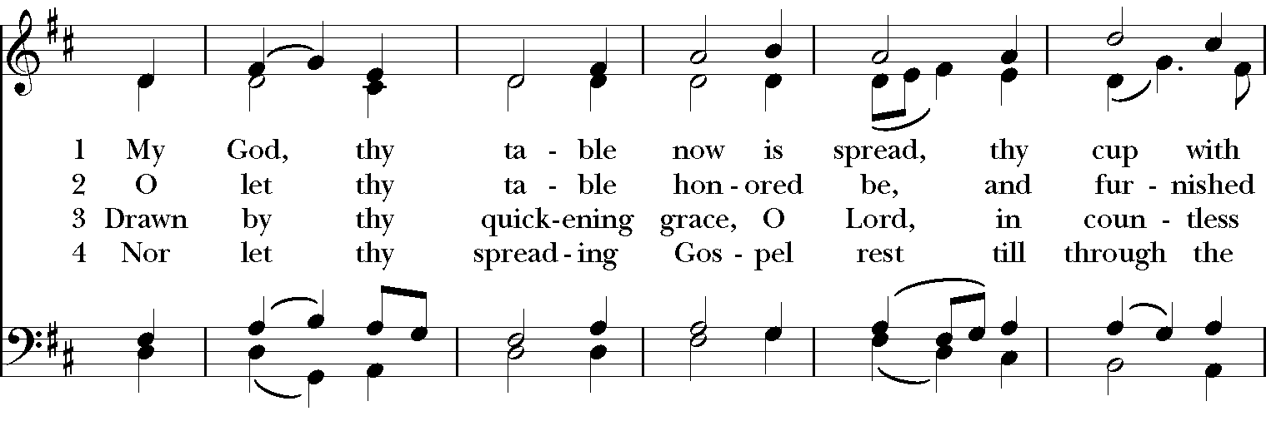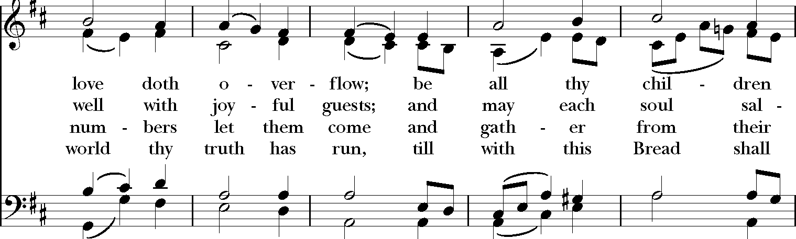
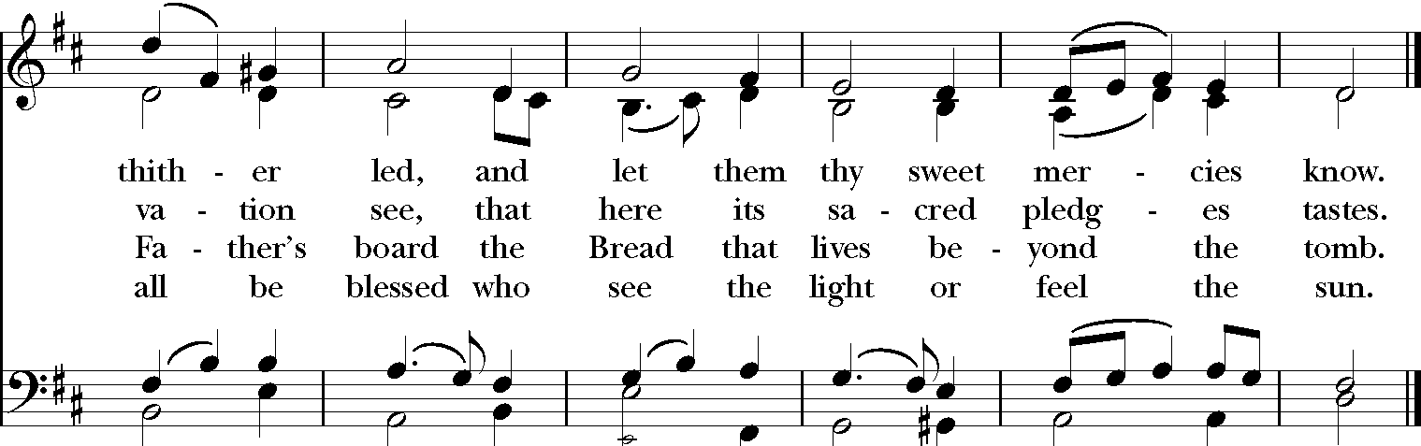
The Holy Communion
The Prayer over the Gifts
God of compassion and forgiveness, receive our offering this day, and make us one with him who is our peace, Jesus Christ our Saviour. Amen.

The Great Thanksgiving
It is indeed right that we should praise you, gracious God, for you created all things. You formed us in your own image: you created us. When we turned away from you in sin, you did not cease to care for us, but opened a path of salvation for all people.
You made a covenant with Israel, and through your servants Abraham and Sarah gave the promise of a blessing to all nations. Through Moses you led your people from bondage into freedom; through the prophets you renewed your promise of salvation.
Therefore, with them, and with all your saints who have served you in every age, we give thanks and raise our voices to proclaim the glory of your name.

The Sanctus & Benedictus Community Mass R. Proulx (1937-2010)
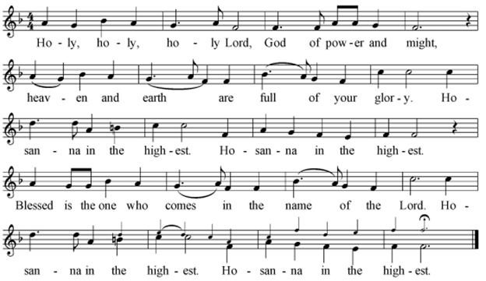
The Celebrant continues
Holy God, source of life and goodness, all creation rightly gives you praise. In the fullness of time, you sent your Son Jesus Christ, to share our human nature, to live and die as one of us, to reconcile us to you,
the God and Father of all. He healed the sick and ate and drank with outcasts and sinners; he opened the eyes of the blind and proclaimed the good news of your kingdom to the poor and to those in need. In all things he fulfilled your gracious will.
On the night he freely gave himself to death, our Lord Jesus Christ took bread, and when he had given thanks to you, he broke it, and gave it to his disciples, and said, “Take, eat: this is my body which is given for you. Do this for the remembrance of me.”
After supper he took the cup of wine; and when he had given thanks,
he gave it to them, and said, “Drink this, all of you: this is my blood of the new covenant, which is shed for you and for many for the forgiveness of sins. Whenever you drink it, do this for the remembrance of me.”

Gracious God, his perfect sacrifice destroys the power of sin and death; by raising him to life you give us life for evermore.
Therefore we proclaim the mystery of faith.
Christ has died.
Christ is risen.
Christ will come again.
Recalling his death, proclaiming his resurrection, and looking for his coming again in glory, we offer you, Father, this bread and this cup. Send your Holy Spirit upon us and upon these gifts, that all who eat and drink at this table may be one body and one holy people, a living sacrifice in Jesus Christ, our Lord. Through Christ, with Christ, and in Christ, in the unity of the Holy Spirit, all glory is yours, almighty Father, now and for ever. Amen.
The Lord’s Prayer
And now, as our Saviour Christ has taught us, we are bold to say,
Our Father,
who art in heaven,
hallowed be thy name,
Thy kingdom come,
thy will be done,
on earth as it is in heaven.
Give us this day our daily bread.
And forgive us our trespasses,
as we forgive those who trespass against us.
And lead us not into temptation,
but deliver us from evil.
For thine is the kingdom,
the power, and the glory,
for ever and ever. Amen.
The Breaking of the Bread
The Celebrant breaks the consecrated bread.
We break this bread to share in the body of Christ.
We, being many, are one body, for we all share in the one bread.
The Fraction Anthem Mass of St. George Andrew Wells (b.1962)
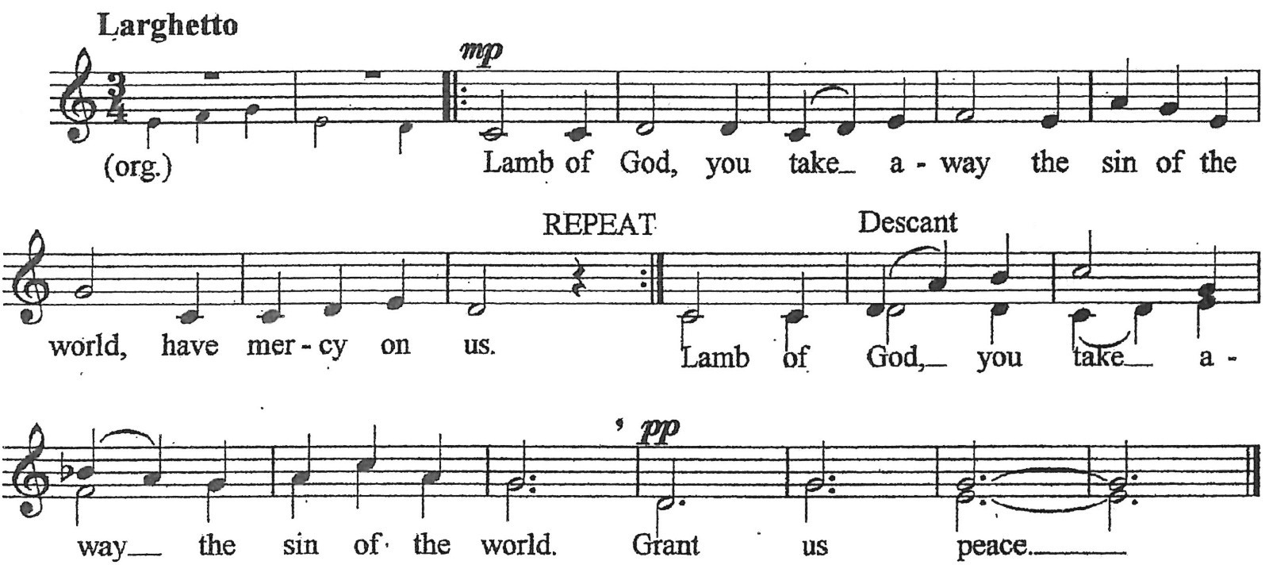
The Invitation to Holy Communion
The gifts of God for the people of God.
Thanks be to God.
We invite all baptized Christians to receive the sacrament of Holy Communion. If you prefer to receive a blessing instead of the bread and wine, you may indicate that desire by crossing your arms over your chest. If you are unable to come forward, please ask a sidesperson to have Communion brought to you.
Communion Anthem Laudate Dominum (from Vespers K. 339)
Wolfgang Amadeus Mozart (1756-1791)

O praise the Lord, all ye nations: praise him, all ye people.
For his merciful kindness is great toward us:
and the truth of the Lord endureth for ever.

Glory be to the Father, and to the Son,
and to the Holy Ghost.
As it was in the beginning is now, and ever shall be,
world without end. Amen.

Please stand as you are able.
The Prayer after Communion
Eternal God, in you we find peace beyond all telling. May we who share in this heavenly banquet be instruments of your peace on earth, in the name of Jesus Christ the Lord. Amen.
The Doxology
Glory to God, whose power, working in us, can do infinitely more than we can ask or imagine. Glory to God from generation to generation, in the Church and in Christ Jesus, for ever and ever. Amen.
Please be seated.
The Notices
Please stand as you are able.
The Blessing
The peace of God which passes all understanding keep your hearts and minds in the knowledge and love of God, and of God’s Son, Jesus Christ our Lord; and the blessing of God almighty, the Father, Son, and Holy Spirit, be among you and remain with you always. Amen.
Hymn Nettleton
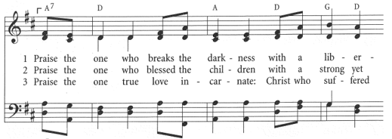
The Dismissal
Let us go forth in the name of Christ.
Thanks be to God.
Voluntary Fantasia in F: Allegro WA Mozart

Please remain standing as the procession leaves the church. Though some people choose to stay for the entire organ postlude, please feel welcome to depart when the Spirit moves you. We hope you will join us for coffee and refreshments in the Trendell Lounge after the service.

St. John’s, Shaughnessy Staff and Leadership
Please contact the parish office if you would like to be added to our mailing list, so that we may let you know about upcoming events.
Clergy and Staff
The Reverend Terry Shields Dirbas, Rector terry.dirbas@sjs.net
The Reverend James Hwang, Curate jhwang@sjs.net
The Reverend Dr. Marilyn Hames, Honorary Assisting Priest
The Reverend Karin Fulcher, Deacon (Retired)
The Reverend Pitman Potter, Deacon (Retired)
Dr. Graeme Langager, Choral Director graeme.langager@sjs.net
Michael Dirk, Principal Organist and Artist-in-Residence organist@sjs.net
Deanna Ferguson, Parish Administrator church.office@sjs.net
Trustees
The Rev. Terry Shields Dirbas, Rector
Ken Pepin, Rector’s Warden ken.pepin@sjsparish.net
Joan Stewart, People’s Warden joan.stewart@sjsparish.net
Mike Dezell mike.dezell@sjsparish.net
Catherine Holmen catherine.holmen@sjsparish.net

1490 Nanton Ave. Vancouver, BC, V6H 2E2
(604) 731-4966
www.sjs.net

